파일 전송 시스템

1. Server

1.1 프로젝트 생성

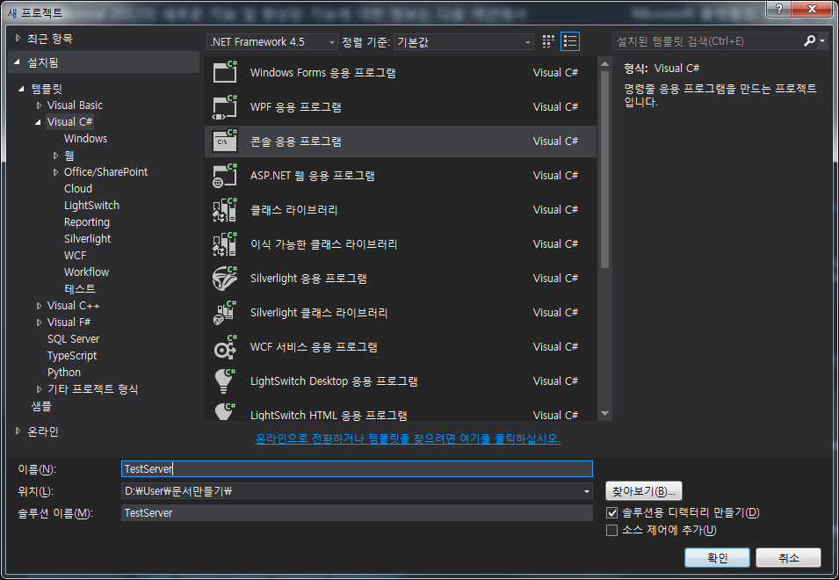

1.2 인터페이스(IService.cs) 작성

1.2.1 IFile 작성

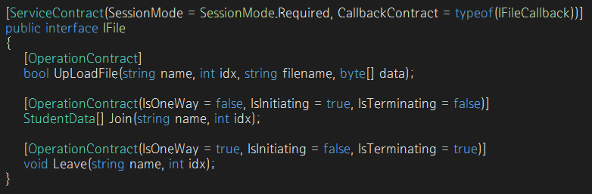

1.2.2 IFileCallback 작성

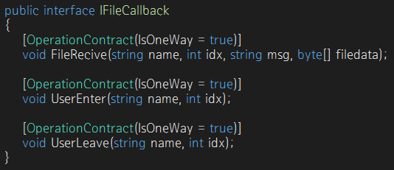

1.2.3 StudentData 작성

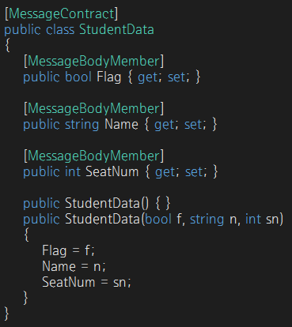

1.3 클래스 파일(CFile.cs) 구현 => 인터페이스 상속.

1.3.1 변수선언

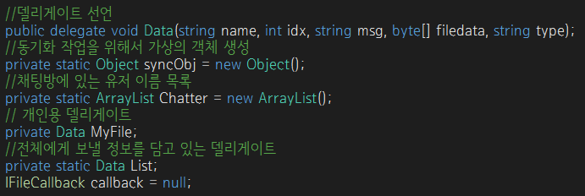

1.3.2 UploadFile(string name, int idx, string filename, byte[] data)

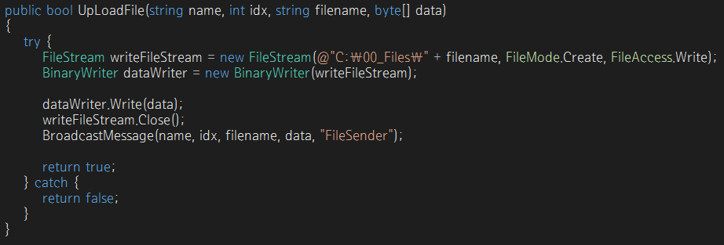

1.3.3 Join(string name, int idx)

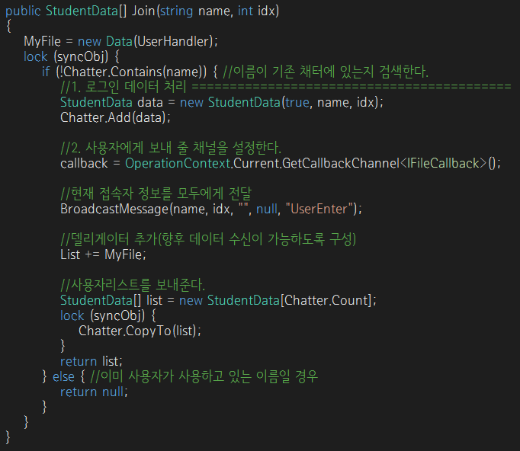

1.3.4 Leave(string name, int idx)

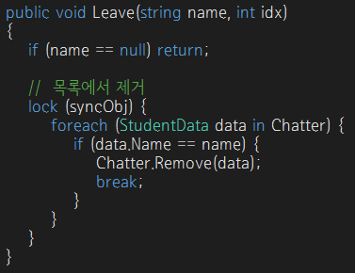

1.3.5 BroadcastMessage(string name, int idx, string msg, byte[] filedata, string msgType)

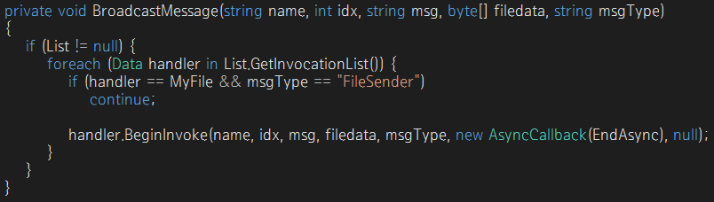

1.3.6 EndAsync(IAsyncResult ar)

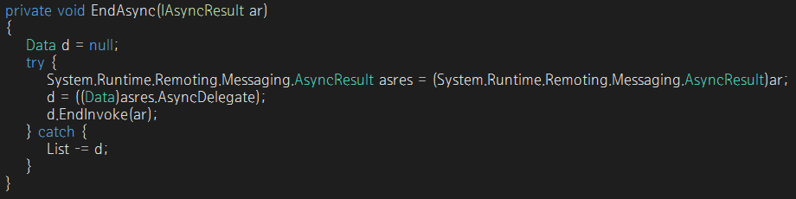

1.3.7 UserHandler(string name, int idx, string msg, byte[] filedata, string msgType)

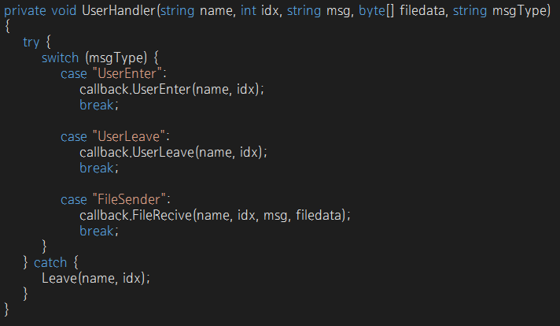

1.4 메인 함수(Programs.cs) 작성

ServiceHost host = new ServiceHost(typeof(서비스이름.클래스), uri);

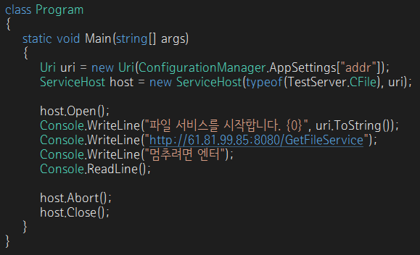

1.4 App.config 작성

|  |
| --- |
| <?xml version="1.0" encoding="utf-8" ?>  <configuration>  <startup>  <supportedRuntime version="v4.0" sku=".NETFramework,Version=v4.5" />  </startup>  <appSettings>  <add key="addr" value="net.tcp://61.81.99.85:3000/FileService"/>  </appSettings>  <system.serviceModel>  <services>  <service behaviorConfiguration="FileServiceBehavior" name="TestServer.CFile">  <endpoint address="" binding="netTcpBinding" bindingConfiguration="DuplexBinding"  contract="TestServer.IFile" />  <host>  <baseAddresses>  <add baseAddress="http://61.81.99.85:8080/GetFileService" />  </baseAddresses>  </host>  </service>  </services>  <bindings>  <netTcpBinding>  <binding name="DuplexBinding" maxBufferPoolSize="2147483647"  maxBufferSize="2147483647" maxConnections="100" maxReceivedMessageSize="2147483647">  <reliableSession enabled="true" />  <security mode="None" />  </binding>  </netTcpBinding>  </bindings>  <behaviors>  <serviceBehaviors>  <behavior name="FileServiceBehavior">  <serviceMetadata httpGetEnabled="true"/>  <serviceDebug includeExceptionDetailInFaults="true"/>  </behavior>  </serviceBehaviors>  </behaviors>  </system.serviceModel>  </configuration> |

2. Client

2.1 서비스 참조 추가

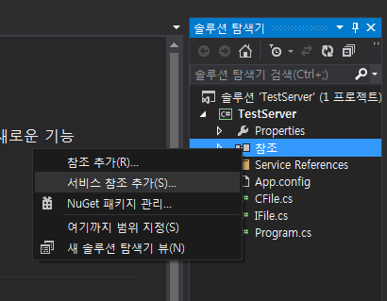

3.2 주소 설정 및 확인

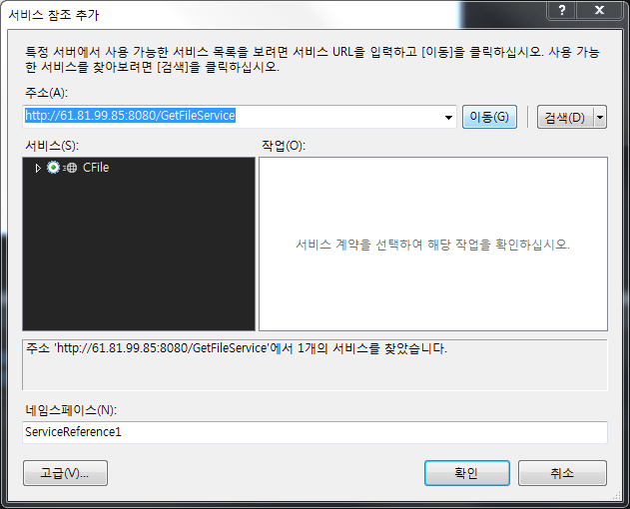

3.3 using namespace 추가

D:\User\문서만들기\Pic\35.PNG

3.4 XAML 파일 작성

|  |
| --- |
| <Window x:Class="TestClient.MainWindow"  xmlns="http://schemas.microsoft.com/winfx/2006/xaml/presentation"  xmlns:x="http://schemas.microsoft.com/winfx/2006/xaml"  Title="MainWindow" Height="530" Width="747" Loaded="Window_Loaded">  <Grid>  <TextBox Name="namebox" HorizontalAlignment="Left" Height="23" Margin="155,26,0,0" TextWrapping="Wrap" Text="이름을 입력하세요." VerticalAlignment="Top" Width="158" TextAlignment="Center" GotFocus="namebox_GotFocus"/>  <TextBox Name="seatbox" HorizontalAlignment="Left" Height="23" Margin="155,54,0,0" TextWrapping="Wrap" Text="좌석을 선택하세요." VerticalAlignment="Top" Width="158" TextAlignment="Center"/>  <Button Name="btnJoin" Content="로그인" HorizontalAlignment="Left" Margin="318,26,0,0" VerticalAlignment="Top" Width="75" Height="51" Click="btnJoin_Click"/>  <TextBox Name="textbox01" HorizontalAlignment="Left" Height="80" Margin="10,26,0,0" TextWrapping="Wrap" VerticalAlignment="Top" Width="80" TextAlignment="Center"/>  <TextBox Name="textbox02" HorizontalAlignment="Left" Height="80" Margin="10,146,0,0" TextWrapping="Wrap" VerticalAlignment="Top" Width="80" TextAlignment="Center"/>  <TextBox Name="textbox03" HorizontalAlignment="Left" Height="80" Margin="110,146,0,0" TextWrapping="Wrap" VerticalAlignment="Top" Width="80" TextAlignment="Center"/>  <TextBox Name="textbox04" HorizontalAlignment="Left" Height="80" Margin="212,146,0,0" TextWrapping="Wrap" VerticalAlignment="Top" Width="80" TextAlignment="Center"/>  <TextBox Name="textbox05" HorizontalAlignment="Left" Height="80" Margin="313,146,0,0" TextWrapping="Wrap" VerticalAlignment="Top" Width="80" TextAlignment="Center"/>  <TextBox Name="textbox06" HorizontalAlignment="Left" Height="80" Margin="425,146,0,0" TextWrapping="Wrap" VerticalAlignment="Top" Width="80" TextAlignment="Center"/>  <TextBox Name="textbox07" HorizontalAlignment="Left" Height="80" Margin="529,146,0,0" TextWrapping="Wrap" VerticalAlignment="Top" Width="80" TextAlignment="Center"/>  <TextBox Name="textbox08" HorizontalAlignment="Left" Height="80" Margin="634,146,0,0" TextWrapping="Wrap" VerticalAlignment="Top" Width="80" TextAlignment="Center"/>  <TextBox Name="textbox09" HorizontalAlignment="Left" Height="80" Margin="10,266,0,0" TextWrapping="Wrap" VerticalAlignment="Top" Width="80" TextAlignment="Center"/>  <TextBox Name="textbox10" HorizontalAlignment="Left" Height="80" Margin="110,266,0,0" TextWrapping="Wrap" VerticalAlignment="Top" Width="80" TextAlignment="Center"/>  <TextBox Name="textbox11" HorizontalAlignment="Left" Height="80" Margin="212,266,0,0" TextWrapping="Wrap" VerticalAlignment="Top" Width="80" TextAlignment="Center"/>  <TextBox Name="textbox12" HorizontalAlignment="Left" Height="80" Margin="313,266,0,0" TextWrapping="Wrap" VerticalAlignment="Top" Width="80" TextAlignment="Center"/>  <TextBox Name="textbox13" HorizontalAlignment="Left" Height="80" Margin="425,266,0,0" TextWrapping="Wrap" VerticalAlignment="Top" Width="80" TextAlignment="Center"/>  <TextBox Name="textbox14" HorizontalAlignment="Left" Height="80" Margin="529,266,0,0" TextWrapping="Wrap" VerticalAlignment="Top" Width="80" TextAlignment="Center"/>  <TextBox Name="textbox15" HorizontalAlignment="Left" Height="80" Margin="634,266,0,0" TextWrapping="Wrap" VerticalAlignment="Top" Width="80" TextAlignment="Center"/>  <TextBox Name="textbox16" HorizontalAlignment="Left" Height="80" Margin="10,390,0,0" TextWrapping="Wrap" VerticalAlignment="Top" Width="80" TextAlignment="Center"/>  <TextBox Name="textbox17" HorizontalAlignment="Left" Height="80" Margin="110,390,0,0" TextWrapping="Wrap" VerticalAlignment="Top" Width="80" TextAlignment="Center"/>  <TextBox Name="textbox18" HorizontalAlignment="Left" Height="80" Margin="212,390,0,0" TextWrapping="Wrap" VerticalAlignment="Top" Width="80" TextAlignment="Center"/>  <TextBox Name="textbox19" HorizontalAlignment="Left" Height="80" Margin="313,390,0,0" TextWrapping="Wrap" VerticalAlignment="Top" Width="80" TextAlignment="Center"/>  <TextBox Name="textbox20" HorizontalAlignment="Left" Height="80" Margin="425,390,0,0" TextWrapping="Wrap" VerticalAlignment="Top" Width="80" TextAlignment="Center"/>  <TextBox Name="textbox21" HorizontalAlignment="Left" Height="80" Margin="529,390,0,0" TextWrapping="Wrap" VerticalAlignment="Top" Width="80" TextAlignment="Center"/>  <TextBox Name="textbox22" HorizontalAlignment="Left" Height="80" Margin="634,390,0,0" TextWrapping="Wrap" VerticalAlignment="Top" Width="80" TextAlignment="Center"/>  <Label Content="1" HorizontalAlignment="Left" Margin="6,22,0,0" VerticalAlignment="Top" Width="26" Background="#FF939393" FontWeight="Bold" MouseDown="Label_MouseDown"/>  <Label Content="2" HorizontalAlignment="Left" Margin="6,142,0,0" VerticalAlignment="Top" Width="26" Background="#FF939393" FontWeight="Bold" MouseDown="Label_MouseDown"/>  <Label Content="3" HorizontalAlignment="Left" Margin="105,142,0,0" VerticalAlignment="Top" Width="26" Background="#FF939393" FontWeight="Bold" MouseDown="Label_MouseDown"/>  <Label Content="4" HorizontalAlignment="Left" Margin="207,142,0,0" VerticalAlignment="Top" Width="26" Background="#FF939393" FontWeight="Bold" MouseDown="Label_MouseDown"/>  <Label Content="5" HorizontalAlignment="Left" Margin="308,142,0,0" VerticalAlignment="Top" Width="26" Background="#FF939393" FontWeight="Bold" MouseDown="Label_MouseDown"/>  <Label Content="6" HorizontalAlignment="Left" Margin="420,142,0,0" VerticalAlignment="Top" Width="26" Background="#FF939393" FontWeight="Bold" MouseDown="Label_MouseDown"/>  <Label Content="7" HorizontalAlignment="Left" Margin="525,142,0,0" VerticalAlignment="Top" Width="26" Background="#FF939393" FontWeight="Bold" MouseDown="Label_MouseDown"/>  <Label Content="8" HorizontalAlignment="Left" Margin="629,142,0,0" VerticalAlignment="Top" Width="26" Background="#FF939393" FontWeight="Bold" MouseDown="Label_MouseDown"/>  <Label Content="9" HorizontalAlignment="Left" Margin="6,263,0,0" VerticalAlignment="Top" Width="26" Background="#FF939393" FontWeight="Bold" MouseDown="Label_MouseDown"/>  <Label Content="10" HorizontalAlignment="Left" Margin="105,263,0,0" VerticalAlignment="Top" Width="26" Background="#FF939393" FontWeight="Bold" MouseDown="Label_MouseDown"/>  <Label Content="11" HorizontalAlignment="Left" Margin="207,263,0,0" VerticalAlignment="Top" Width="26" Background="#FF939393" FontWeight="Bold" MouseDown="Label_MouseDown"/>  <Label Content="12" HorizontalAlignment="Left" Margin="308,263,0,0" VerticalAlignment="Top" Width="26" Background="#FF939393" FontWeight="Bold" MouseDown="Label_MouseDown"/>  <Label Content="13" HorizontalAlignment="Left" Margin="420,263,0,0" VerticalAlignment="Top" Width="26" Background="#FF939393" FontWeight="Bold" MouseDown="Label_MouseDown"/>  <Label Content="14" HorizontalAlignment="Left" Margin="525,263,0,0" VerticalAlignment="Top" Width="26" Background="#FF939393" FontWeight="Bold" MouseDown="Label_MouseDown"/>  <Label Content="15" HorizontalAlignment="Left" Margin="629,263,0,0" VerticalAlignment="Top" Width="26" Background="#FF939393" FontWeight="Bold" MouseDown="Label_MouseDown"/>  <Label Content="16" HorizontalAlignment="Left" Margin="6,386,0,0" VerticalAlignment="Top" Width="26" Background="#FF939393" FontWeight="Bold" MouseDown="Label_MouseDown"/>  <Label Content="17" HorizontalAlignment="Left" Margin="105,386,0,0" VerticalAlignment="Top" Width="26" Background="#FF939393" FontWeight="Bold" MouseDown="Label_MouseDown"/>  <Label Content="18" HorizontalAlignment="Left" Margin="207,386,0,0" VerticalAlignment="Top" Width="26" Background="#FF939393" FontWeight="Bold" MouseDown="Label_MouseDown"/>  <Label Content="19" HorizontalAlignment="Left" Margin="308,386,0,0" VerticalAlignment="Top" Width="26" Background="#FF939393" FontWeight="Bold" MouseDown="Label_MouseDown"/>  <Label Content="20" HorizontalAlignment="Left" Margin="420,386,0,0" VerticalAlignment="Top" Width="26" Background="#FF939393" FontWeight="Bold" MouseDown="Label_MouseDown"/>  <Label Content="21" HorizontalAlignment="Left" Margin="525,386,0,0" VerticalAlignment="Top" Width="26" Background="#FF939393" FontWeight="Bold" MouseDown="Label_MouseDown"/>  <Label Content="22" HorizontalAlignment="Left" Margin="629,386,0,0" VerticalAlignment="Top" Width="26" Background="#FF939393" FontWeight="Bold" MouseDown="Label_MouseDown"/>  <GroupBox Header="파일 업로드" HorizontalAlignment="Left" Margin="433,12,0,0" VerticalAlignment="Top" Height="110" Width="281">  <Grid Margin="10,10,11,7">  <TextBox Name="txtUpLoad1" Margin="10,5,93,40" />  <Button Name="btnOpen" Click="btnOpen_Click" Content="파일열기" Width="78" Height="28" Margin="77,36,93,7" />  <Button Name="btnUpload" Click="btnUpload_Click" Content="업로드" Margin="160,4,10,0" Width="78" Height="28" VerticalAlignment="Top" />  <Button Name="btnAllSend" Click="btnAllSend_Click" Content="전체업로드" HorizontalAlignment="Left" Margin="160,37,0,0" VerticalAlignment="Top" Width="78" Height="28"/>  </Grid>  </GroupBox>  </Grid>  </Window> |

3.5 XAML.CS 파일 작성

3.5.1 변수 선언

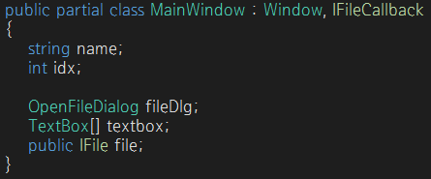

3.5.2 생성자 설정

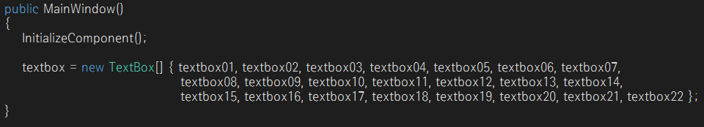

3.5.3 초기 화면 설정

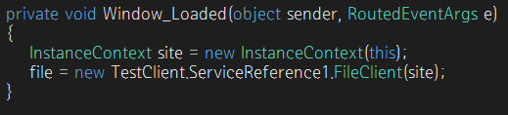

3.5.4 UserEnter(string name, int idx)

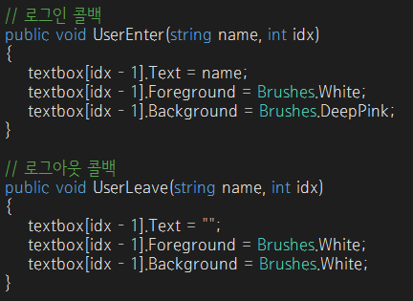

3.5.5 UserLeave(string name, int idx)



3.5.6 로그인 버튼 설정

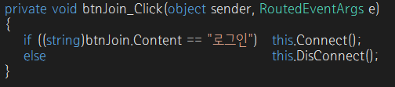

3.5.7 Connect 설정

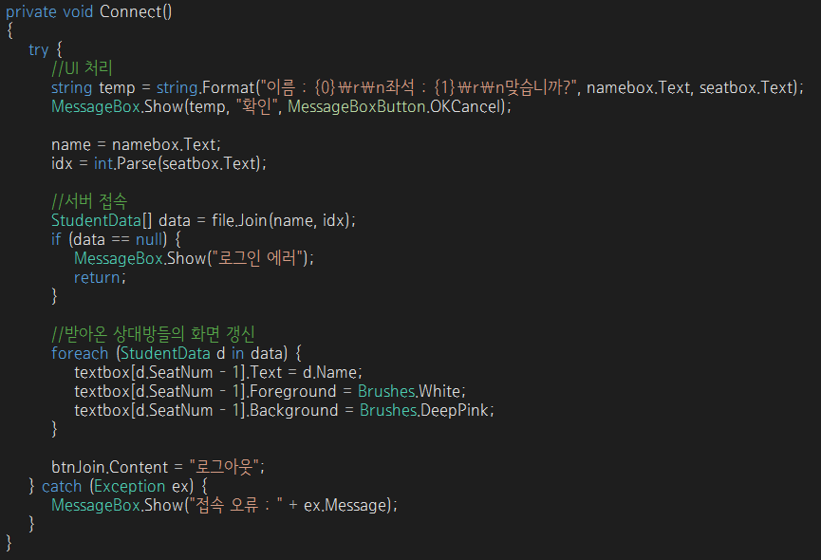

3.5.8 DisConnect 설정

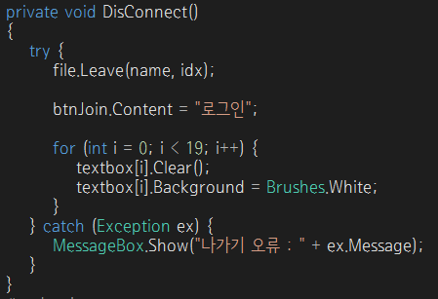

3.5.9 클릭 메서드 작성

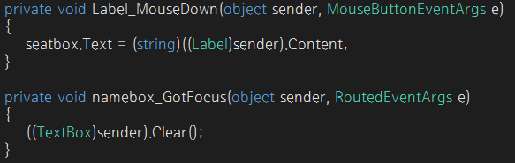

3.5.10 FileRecive(string senderName, int idx, string filename, byte[] filedata)

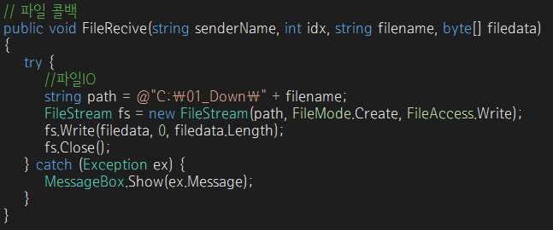

3.5.11 파일 열기 다이얼로그 작성

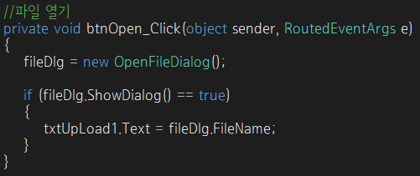

3.5.11 파일 전송 (1:1)

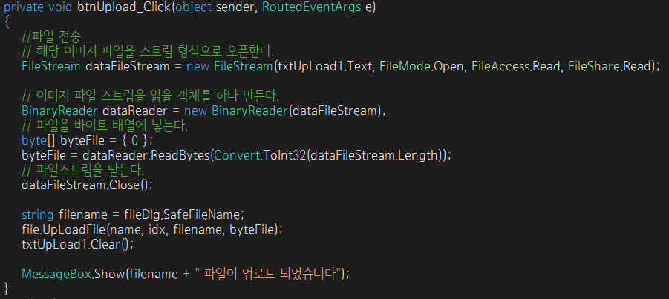

3.5.12 파일 전송 (1:多)

